1) Write two different queries that would produce all orders taken on October 3rd or 4th , 1990

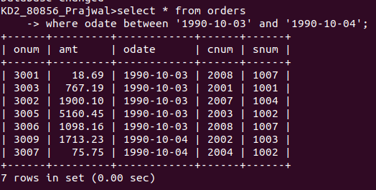

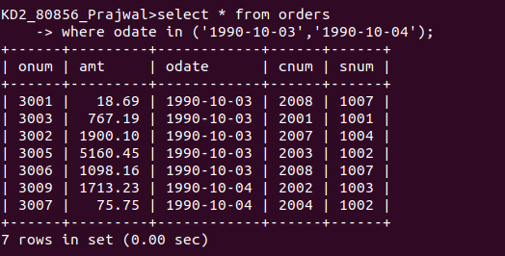
OR

2) write a query that selects all of the customers serviced by Peel or Motika.

As we are yet to learn joins hence we will find out Snum of Peel and Motika from SALESPEOPLE
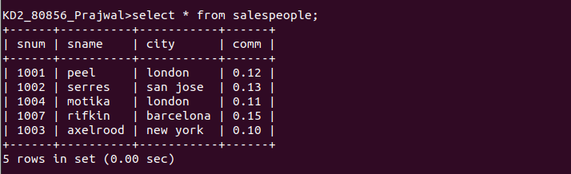
Now we will find out Customers who were serviced by Peel and Motika from CUSTOMERS with help of Snum as it relates two tables to one another
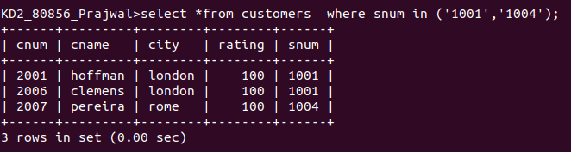

3) Write a query that will produce all the customers whose names begin with a letter from ‘A’ to ‘G’.

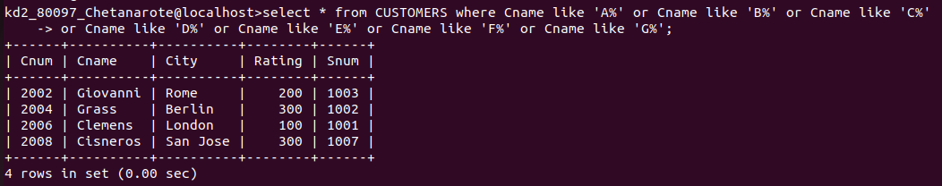

4) Write a query that selects all the customers whose names begin with the letter from ‘C’

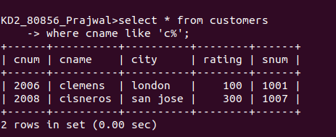

5) Write query that selects all orders except those with zeroes or nulls in the Amt field.

